**DATA LINK LAYER & MEDIUM ACCESS SUB-LAYER**

**Error Detection & Correction**

Data link layer:-

* Each frame must be **distinguishable** from each other.
* Data is between header & trailer.
* **Header:** A code which helps in transmitting data to next node.
* **Trailer:** A code used for error detection & correction.

Protocols at data link layer:-

* Byte oriented protocol
* Bit oriented protocol

Sample frame of data link layer:-

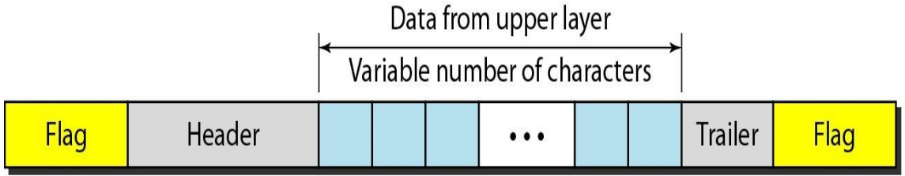

* **Flag:** A fixed pattern used for indicating starting & ending of a flag.
* Header contains **MAC address** of source & destination **+** **control flow info**.

**Byte Oriented Protocol**

* This protocol reads data in terms of **bytes**.
* In this, data contains certain **control patterns** & thus **extra bytes** are stuffed into it in order to avoid conflict.
* We call these stuffed data as **ESC**.
* **ESC:** Extra stuffed characters.
* If ESC is found in data, then **additional ESCs** are stuffed. So that when **ESC-Flag** or **ESC-ESC** pattern is noticed, receiving device can understand that it is part of data.

**Bit Oriented Protocol**

* When code **0111 1110** appears, it is **mistaken** as a **flag**.
* So after each **5th** 1, a **0** is stuffed which is removed at receiver’s end.

**Types of Errors**

* **Single bit error:** ***\*As the name says.\****
* **Burst error:** Errors in which more than two bits are changed.

**Error Correction**

* For correcting the error, some extra bits of data are sent.

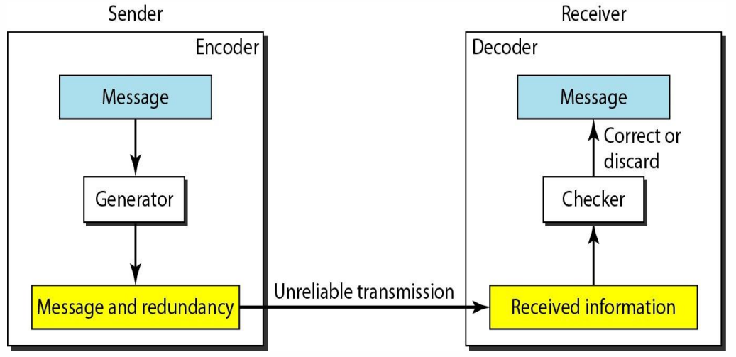

**Detection v/s Correction**

|  |  |
| --- | --- |
| **Detection** | **Correction** |
| **Not much difficult.** | **Is difficult.** |
| **Just detects if error exists or not, magnitude is not a concern.** | **Gotta know the size & location of the error with some mathematical calculations.** |

**Error Correction Methods**

* Forward error correction
* Retransmission
* XORing

**Forward Error Correction Method**

* Receiver guesses the correct data seeing the **redundant bits**.
* **Redundant bits:** Bits inserted into original data in order to avoid errors.
* This method is used generally in wireless transmission cases due to high burst error length.
* **For example:**

**Data = 0011 = 0 0 1 1**

**After adding redundant bits, data = 000 000 111 111**

* So, more **0s** in a pack of **3** (pack size may vary) denotes **0**.
* And similarly, more **1s** in a pack denotes value as **1**.

**Let’s say that 000 000 111 111 becomes 001 000 111 111**

**Third letter of first pack is changed as an error.**

**But because majority values in pack are 0, it is considered 0.**

**Hence, 001 000 111 111 = 0 0 1 1 = 0011**

**Retransmission Method**

* This method is used when **error length** is less.
* Receiver detects if an error is occurring or not.
* If yes, then **requests** the transmitter for resending the data.
* When the data is found error free, the process is terminated.

**Redundancy Codes**

Types of redundancy coding schemes:-

* Block coding
* Convolution coding

**XORing**

* This is done by **bitwise XOR** operation between 2 consecutive transmissions of same data.
* **For example:**

**Data 1 = 0010, Data 2 = 0010**

**Now, (Data 1) XOR (Data 2) = 0000 [All 0 bits means no error]**

**Data 1 = 1011, Data 2 = 1001**

**Now, (Data 1) XOR (Data 2) = 0010 [Even one 1 found means error]**

**Block Coding**

* The code is divided into group of **k-bits**.
* **Data words:** ***\*k above\****
* And then redundancy bits are added to each group, so **n = k + r**
* **Code word: *\*n above\****
* **Can’t** detect error of more than **2 bits**.

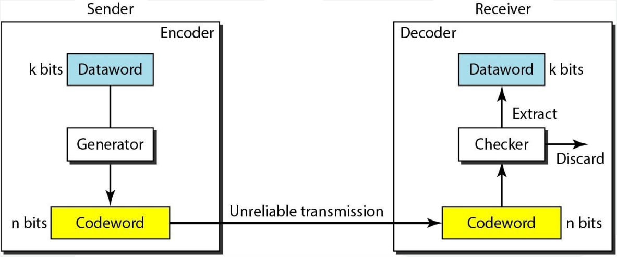

* **For example:**

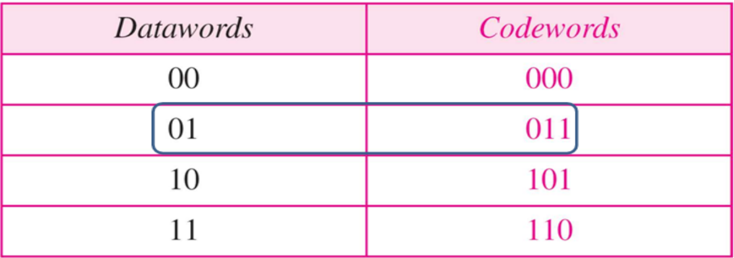

**Let’s say that k=2, n=3 as shown above in the table.**

**For 01 -> 011, 01 is detected and thus is passed successfully.**

**But if it is 000 instead, the error is of more than 2-bits making it undetectable.**

**It is undetected because 000 exists in the table for another value.**

* **Another example:**

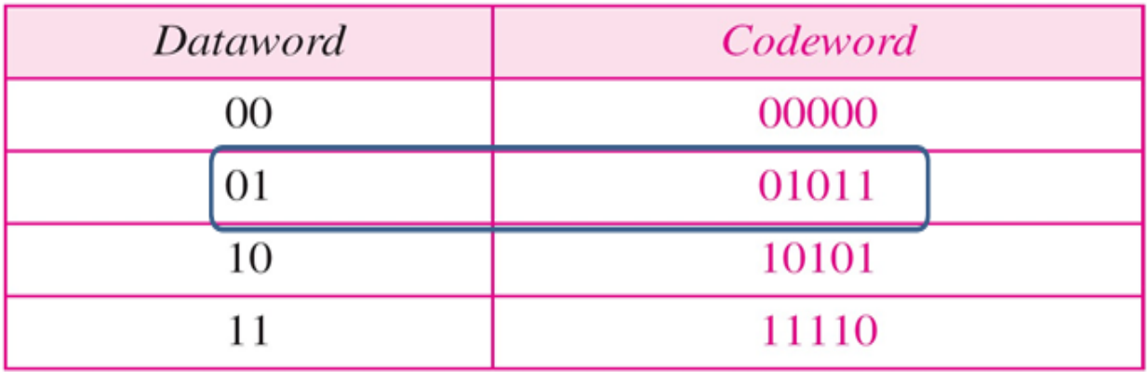

**In this, user receives a corrupted codeword instead 01011.**

**Then user manually matches it with each codeword from table, finding the difference being of 2-bits.**

**Whereas the match with second codeword is of 1-bit difference.**

**And comes to know that in which codeword the error was.**

**Linear Block Codes**

* Subset of **block codes**.
* In this, when we calculate **XOR** of two valid codewords, we get another valid codeword.

**Parity Check Code**

* A type of **simple block code**.

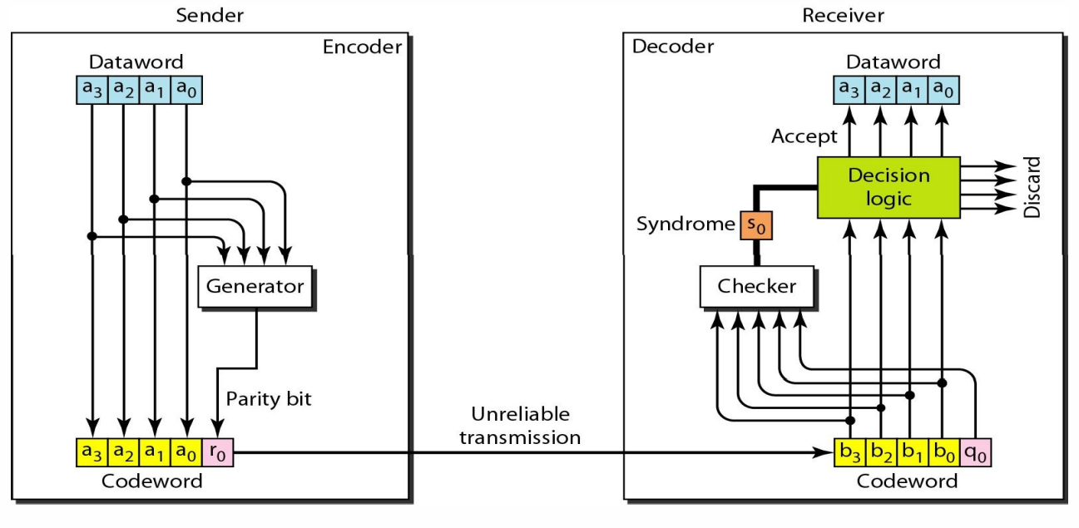

* Hence, number of digits in **codeword** is one more than **dataword**.

**n = k + 1**

* Value of **syndrome** is **0** if **1s** in codeword are even (including **parity bit**).
* And for **odd 1s** it is **1**.
* The parity bit is chosen the same way.

**Cyclic Redundancy Check (CRC)**

* Method used to check if any **accidental change** is made to **signal** during transmission.
* This error occurs in **communication channel**.
* There is a **generator polynomial** on sender’s and receiver’s side, telling **how** data was transmitted.
* **Example:**

**Message received: 1010000**

**Given generator polynomial: x3 + 1**

**x3 + 1 = x3 + x0 = 1.x3 + 1.x0 = 1.x3 + 0.x2 + 0.x1 + 1.x0 = CRC (1001)**

**CRC is of 4-bits.**

**So, append 4 - 1 = 3 zeroes in end of our received message.**

**@ means XOR:**

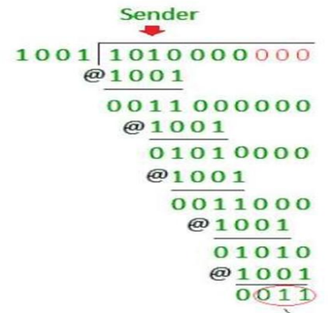

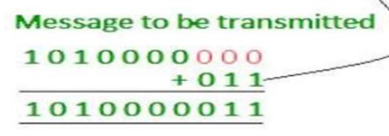

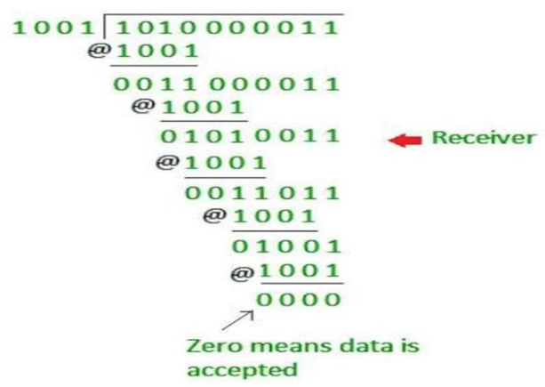

**Checksum**

* Data is divided into **equal** number of bits.
* When before being sent, are segments are **complemented by 1** and **added**, and then their **sum is complemented**.
* This gives us **checksum**, which is sent along the data segments.
* After the receiver receives them, **same procedure** is applied to decode them.
* If it is zero, only then **accepted**.

**Haming Code**

Sender’s end:-

* No limit on the **length** of data to be checked.
* Used for detecting & correcting **single bit errors** only.
* **Parity bits:** All bit positions with serial number equal to **power of 2**.
* **Data bits:** Bit positions **not** equal to power of 2.

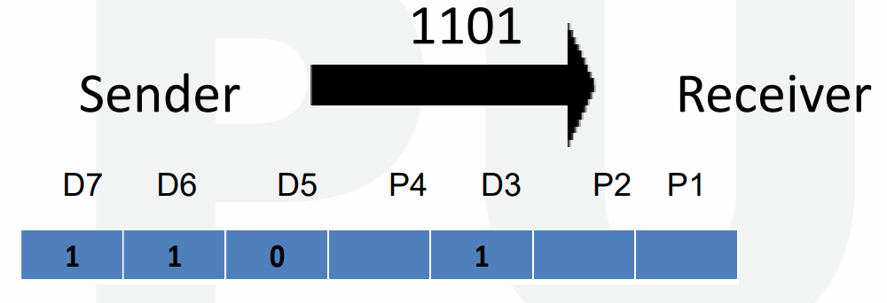

* For **P1**: **1-bit** is checked, **1-bit** is skipped, ***\*repeat\**** (**1,3,5,7**)
* For **P2**: **2-bit** is checked, **2-bit** is skipped, ***\*repeat\**** (**2,3,6,7**)
* For **P4**: **4-bit** is checked, **4-bit** is skipped, ***\*repeat\**** (**4,5,6,7**)

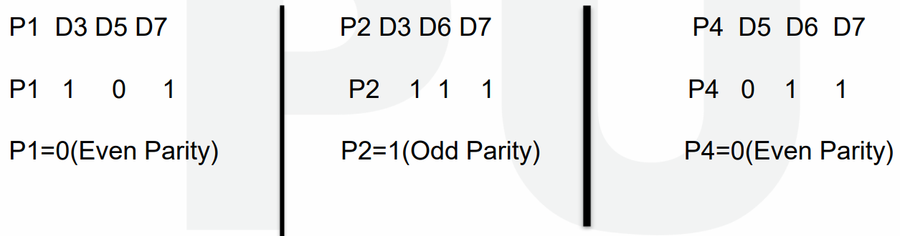

Receiver’s end:-

* If value of all parity bits at receiver’s end is **zero**, then its **free of error**.
* Else it is **not**.

Correction:-

* **Step 1:** Parity bits are written together in series.

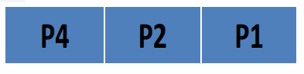

* **Step 2:** This combination is **converted** into **decimal value**.
* **Step 3:** Then the bit at serial number equal to decimal number obtained, is **inverted**.

**Flow & Error Control**

* **Data link layer** ensures flow & error control.
* **Flow control:** Controlling amount of **unacknowledged data** to be sent by sender.
* Error at data link layer is controlled by **retransmission of data**.
* Protocols at this level are implemented using **programming languages**.

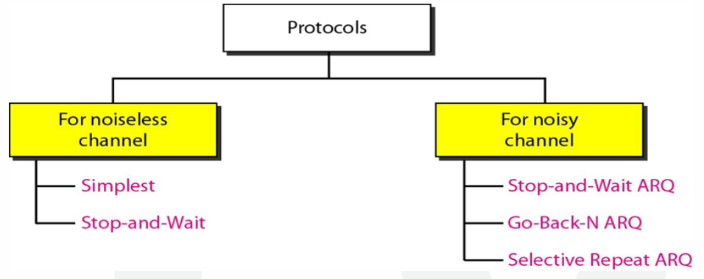

* **Noiseless channel:** Channel through which, **no data are corrupted** while travelling.
* **Noisy channel:** ***\*Now you know\****
* **ARQ:** Automatic repeat request

**Noiseless: Simplex Protocol**

* Different data frames are sent **parallelly**, bit by bit, as **separate events**.
* And definitely, these frames **take time** to reach to the receiver.

**Noisy: Stop and Wait ARQ**

* Error correction is done by **keeping a copy of the frame**, which is sent when the acknowledgement time **expires**.
* These frames being sent are given **serial numbers**.
* Acknowledgement is given frame by frame & next frame is sent only after the **acknowledgment** of **previous frame**.
* Frame is **resent** even when the **acknowledgment fails** to reach the sender.
* After getting the acknowledgement, the copy of frame is **deleted**.
* Bandwidth of channel in **“Stop and Wait ARQ”** is around **1 Mbps**.
* 1 bit of data takes around **20 milliseconds** to be sent.

**Noisy: Sliding Window Protocols (ARQ)**

* Same as **stop and wait** but sender can send **multiple frames** at a time.
* Also known as **windowing**.
* This protocol is also used in **TCP**.
* These messages however passed through **buffers**.
* **Sender** has a buffer called **sending window** & **receiver** has a buffer called **receiving window**.
* **Modulo-N:** All **preceding** whole numbers to a given number **N**.
* **Window size:** The **number of frames** a sending or receiving window **can store**.
* These frames stored in buffers are given **sequence numbers** as per **modulo-N** in binaries, **N** is the **number of frames**.
* Or simply saying, they are given sequence numbers just like **indexes** in programming.

**For example:**

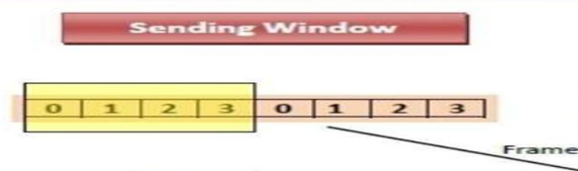

Types:-

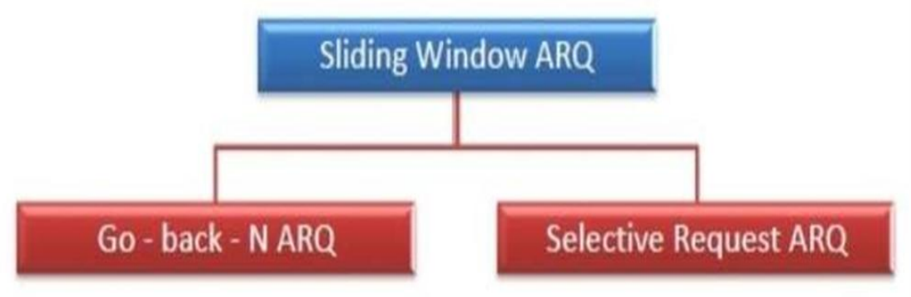

**Sliding Window Protocol: Go Back N (ARQ)**

* In **Go Back N** protocol; if **even a single** frame is **corrupted or lost**, then **all** frames are resent.
* The **sending frame** in it is **N**, whereas **receiving frame** is **1**.
* It also works on the **time expiration** principle.

**Sliding Window Protocol: Selective Repeat (ARQ)**

* In this, the size of **sender** and **receiver window** are **same**.
* **Sliding window size:** Number of frames that could be sent **at a time**.
* If a **corrupt frame** is received, then frames are **not** **discarded** immediately.
* Rather a **negative acknowledgement** is sent when a frame mismatches.
* And then that **particular frame** is **resent** immediately, without waiting for the expiration time.

**Piggybacking**

* A technique in which data can flow **bidirectionally**.
* Unlike previous techniques with a **dedicated sender & receiver**.
* Acknowledgement (**ACK**) & negative acknowledgement (**NAK**) are transmitted along.
* **Separate frames** containing ACK or NAK are sent.
* These frames are of few bits & called **acknowledgement field**.
* **Station:** Points which can receive and send data.

Working principles:-

* If a station has to send both **data and acknowledgement**, then the acknowledgement is sent **along the data**.
* This acknowledgement contains the **serial number of the frame** with it.
* If there is **only an acknowledgement** to be sent, then it waits for some time to see if any data frame is about to be sent.
* If yes, then it **piggybacks** (packs/stuffs) **the acknowledgement** with it.
* Else it sends a **separate** acknowledgement frame.
* If its **only data frame** to be sent, then this data frame is **piggybacked** with **last acknowledgement**; which is discarded by the receiving station.
* Or alternatively, it is **piggybacked** with an acknowledgement saying **no acknowledgement**.

**Multiple Access Protocols (MAP)**

* **Data link layer** is responsible for ensuring **data transmission** between two nodes.

Main functions of MAP are:-

* Data link control
* Multiple access control

**Data Link Control**

* Ensures **reliable** transmission of data.
* Uses techniques like **framing**, **error control** & **flow control**.

**Multiple Access Control**

* **Link:** Channel
* If there is a **dedicated link** between two nodes, then data link layer is **enough**.
* Otherwise a link is **concurrently used** by multiple nodes.
* **Multiple access control** is required to avoid **signal collision** in a common link.
* And it also avoids **mismatched data delivery**.

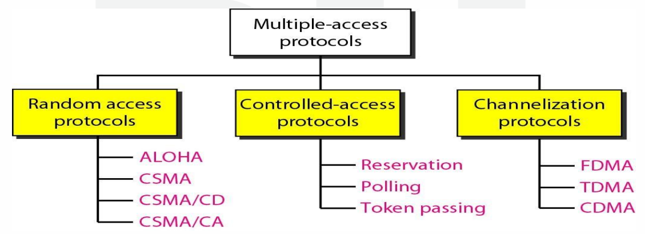

Types of network links:-

* **Point-to-point link:** A sender at one end & a receiver at another end.
* **Broadcast link:** Multiple senders and receivers are linked to **common broadcast** channel.
* Word **broadcast** because the frame transmitted by any sender is received by **all receivers**, as a copy.

**Random Access Protocols (RAP)**

* In this protocol, there is **no priority based** **arrangement** of nodes for sending data.
* All nodes are given **equal priority**.
* However, data transmission depends on whether a medium is **busy** or **idle**.
* There is **no fixed time** for sending data.
* There is also **no fixed sequence** of stations for sending data.

Examples of RAP:-

* Pure ALOHA
* Slotted ALOHA
* CSMA, CSMA/CD, CSMA/CA

**Pure ALOHA Protocol**

* **Throughput** on **pure ALOH**A is maximized when frame length are **similar**.

**Throughput = S = G*(e-2G)**

* Throughput is maximum at **G = ½**

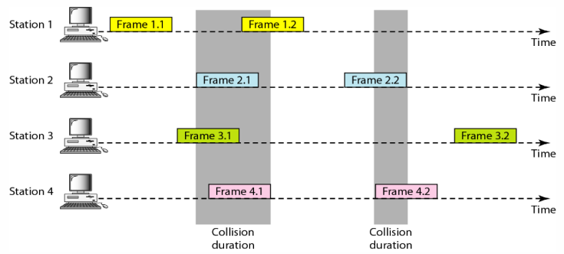

* **Pure ALOHA** allows senders to send data **whenever** **they have them**.
* If a **collision** happens, the sender resends data after sometime (**random time**).
* **Contention system:** Systems with **common channel** & thus **vulnerable** to conflicts.
* Concurrent attempt to access the medium can lead to **distorted signals**.
* **Overlapping bits** of two separate frames have capability to **destroy** each other.

**Slotted Aloha Protocol**

* Created to overcome **pure Aloha’s** shortcomings.
* Time is divided into **slots**.
* Different slots are given to different **stations**.
* When their number comes, they send a frame during their respective slots.
* If any station **misses** the transmission, then it has to **wait** for next round of its slot.

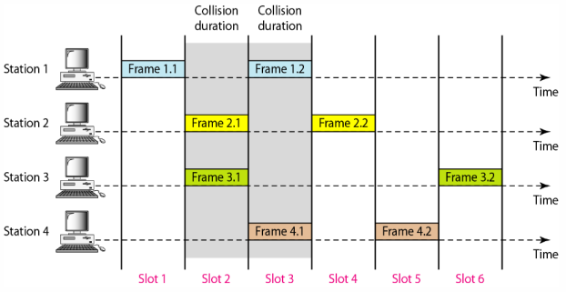

* As we can see, complete overlap of bits **won’t** cause **collision**.

**Throughput = S = G*(e-G)**

* Throughput is maximum at **G = 1**.

**CSMA/CD**

* **CSMA/CS:** CSMA with **collision detection**.
* When a shared channel is **idle**, two stations may begin transmitting data **simultaneously**.
* When this happens, these two stations will **detect collision** immediately.
* And when collision is detected by **CSMA/CD** protocol, a **jamming signal** is sent to **abort** transmission.
* Aborting transmission at such situation saves both **time** and **bandwidth**.
* **Bandwidth:** Transmission energy.

**CSMA/CA**

* In this variant of CSMA, a station receives signal sent to it **despite collision detection**.
* When there is **no collision**, a station receives the signal sent to it.
* But when there is a collision, the station receives signals from **both the senders**.
* In **wired networks**, the detection is **easy** because a **lot of energy** is emitted in it.
* However, the detection becomes **difficult** in **wireless network**.
* Thus, **CSMA/CA** in wireless network **avoids collision**, rather than detecting it.